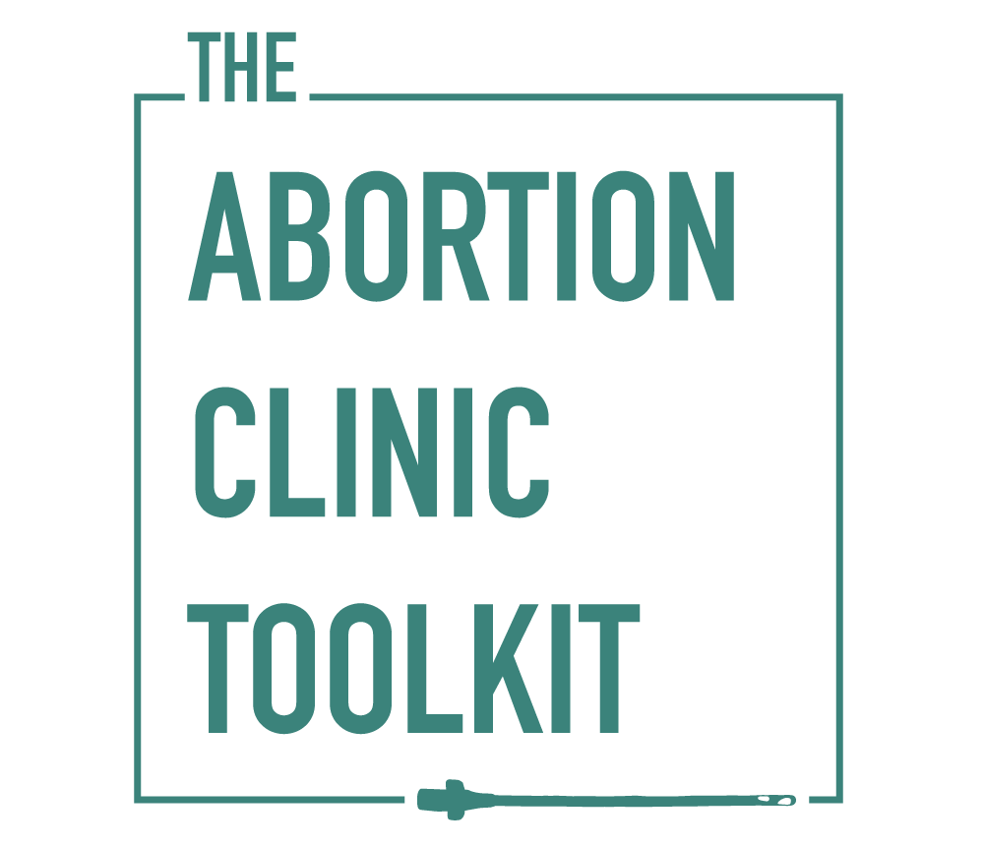

An orientation checklist for new clinicians:
what to be sure to ask about and understand starting day one

There are several location-specific considerations when you start working in a new abortion clinic setting. What follows is a checklist that can serve as a guide to ask questions about the general approach to important scenarios. See www.AbortionClinicToolkit.org for an orientation video and a PDF version of this checklist with space for taking notes (if you want to print it).

PART 1: Steps for getting oriented to the clinic

- Review the clinic’s policies & procedures documents
- Review the paperwork that patients fill out prior to both procedural abortion and medication abortion (to understand payment structure, process, etc.)
- Review the aftercare instructions that patients are given after procedures, medication abortion, and contraception initiation
- Familiarize yourself with the available instruments (e.g. cannulas, forceps, dilators)
- Do a walk-through of the clinic as if you were a patient to understand patient flow
- Do a walk-through of the clinic to pay attention to the emergency equipment
- Do a walk-through of the clinic to pay attention to the security issues in place
- Meet with the security team to understand their role and relevant policies
- Shadow an experienced provider in the clinic for at least one day to get a sense of clinic flow, documentation requirements, etc.
- Ask the questions in parts 2-5 below and take notes

PART 2: Questions that address the internal workings of the clinic

Patient-related
- What are the demographics and characteristics of patients seen here and how does your clinic staff work to serve their needs? (race/ethnicity, socioeconomic status, primary language/need for translator services, gender identity, distance traveled, mental health burden, substance use; issues around immigration, military, school, trauma)
- Does someone screen patients for substance use? Who?
- Is there a protocol for managing patients with substance use disorder?
- Does someone screen patients for safety/intimate partner violence? Who?
- What is done for positive screens?
- How does the clinic address the state’s laws concerning care for minors? How does the clinic staff alter practice (or not) for caring for minors?

- Payment issues:
  - What is the payment structure?
  - Does the clinic take insurance?
  - Do patients pay out of pocket?
    - access abortion funds?
    - Who facilitates patients who are seeking abortion funding assistance?

Staff and management
- Who are the staff members (clinicians and non-clinicians) and what are their roles?
- Who are the staff members who perform the ultrasounds?
- What is the expected experience level of the staff performing ultrasounds? (e.g. CRL, BPD, femur length, placental location, cesarean scar assessment and suspicion for accreta, ectopic pregnancy, r/o retained POCs)
- Who is your clinical point person?
  - What are examples of clinical issues the charge nurse would handle?
  - What are examples of clinical issues the medical director would handle?
- How would I fall into the hierarchy structure when I am here? (e.g. who makes decisions about whether or not a patient is seen?)

PUL (pregnancy of unknown location), ectopic, EPL (early pregnancy loss)
- What systems are in place for PUL or suspected ectopic pregnancy management?
- What are the procedures for managing EPL?
- Does the clinic keep a designated log for beta hCG follow-up?
- Where do patients obtain blood draws and clinical care for PUL/ectopic follow up?
- Does the clinic have the ability to provide methotrexate management?

Contraception
- How / when does contraceptive counseling take place?
- Does the clinic provide post-procedure LARC?
- Do state laws affect contraception prescribing?

Describe the protocols or options available for…
1. Pain management
-identify what levels of sedation are available and under what circumstances they are used
-identify options for patient transport after sedation (i.e. is Lyft/Uber/taxi/bus an option
- pain management for first-trimester procedures?
- pain management for dilator placement?
- pain management for second-trimester procedures?
- pain management in the recovery area?
- sedation reversal?
- pain medications provided or recommended after discharge?
- the medications in the paracervical block? (1% lidocaine? Buffer? Vasopressin- for who?)

2. Intraop
- intraoperative ultrasound? Under what circumstances is it used?

3. Follow-up
- patient follow-up after medication abortion?
- patient follow-up after procedural abortion?

4. If you will be doing procedures >14 weeks
- cervical preparation?
  - Same-day prep, dilators, misoprostol (which routes are used), mifepristone, etc.
  - Know the protocols and WHY the clinic does it this way (i.e. related to patients traveling, state restrictions)

- digoxin and/or KCl?
  - Do providers here do injections routinely? Under what circumstances? Dose, route, where is med stocked?

STI testing, management
- What is the clinicians’ role in STI testing and follow-up of results?

Understand how state restrictions affect clinical management, counseling, and patient flow
- What are the state restrictions?
  - Gestational limits
  - Waiting periods
  - Ultrasound viewing
  - State-mandated counseling
  - Insurance
  - Parental involvement
  - Medication abortion

- Review these websites for additional information
  - The Abortion Law Project, a project of the Center for Public Health Law Research in collaboration with the Guttmacher Institute, National Abortion Federation, Planned Parenthood, Center for Reproductive Rights, and others http://lawatlas.org/page/abortion-law-project
  - Guttmacher Institute
https://www.guttmacher.org/state-policy/explore/overview-abortion-laws
  - NARAL Pro-Choice America
https://www.prochoiceamerica.org/laws-policy/state-government/

Handling unique clinic circumstances
- Do you have learners rotate through the clinic? If so, who and from where?
- If there are learners who rotate through the clinic, understand your teaching obligations:
  - What are the expectations of the learners?
  - What is my expected role for teaching learners?
  - What support is available to me if I take on a teaching role?

- Who handles overnight patient calls?
- If you will be handling overnight patient calls:
  - What are the on-call protocols for managing an overnight emergency?
  - What if a patient needs a D&E outside of standard hours?

- What is the clinic’s approach to management of expulsion both in and out of clinic? What steps do you take to limit the incidence of out-of-clinic expulsion?
- How do you evaluate risk and what types of patients are too high risk to be cared for in this setting? (i.e. is there a policy about certain medical comorbidities, such as prior c-section, obesity, patients on anticoagulation?)

- Does the clinic participate in any research activities? How will that impact clinic flow?

PART 3: Questions that address emergency management in the clinic

- Where are the emergency medications located?
- What uterotonics do you have available?
- Where are the emergency protocols?
- What is the protocol for transferring a patient in the case of an emergency or complication?
  - How do I reach someone at a local hospital? (or, does the protocol include an emergency contact list?)

PART 4: Questions that address the external-to-the-clinic issues

- In what circumstances do you refer patients for a “rule-out accreta” ultrasound?
  - At what gestation and based on which risk factors (# c-sections)
  - Is there a protocol or do different providers here approach this differently?
- Are there hospital(s)/ reliable community allies for emergency transfers?
  - Where is their contact info listed?
- Is there a hospital/clinic in which you have a reliable ally for radiology or MFM services?
  - Where is their contact info listed?
  - Under what circumstances is it appropriate to call any of these allies?
- What are the options for referring patients requiring a hospital-based abortion?
- What are the options if there are no hospital-based abortion services? (i.e. use of contracted CRNA to offer deep sedation as needed)

PART 5: Longer-term questions – get these answered over time

- What are the policies and approach to mandatory reporting (i.e. sexual abuse of minor)?
- Do you perform emergency scenario drills? What topics? How often?
- Are there opportunities to forge better relationships with local hospitals?
- Does the clinic offer free contraception (e.g. OCP samples)?
- What are the local referral networks for follow-up care? (i.e. well-woman exams, sterilization procedures, other primary care)
- What are the safety net systems that patients can access? (i.e. local/state insurance) How do patients enroll?

